Notice to vacate to resident of SDA dwelling
Residential Tenancies Act 1997 (the Act), Part 12A
Specialist Disability Accommodation
Section 498ZX, 498ZZD, 498ZZCA

Note:
Use this form to give notice to vacate if you are a Specialist Disability Accommodation (SDA) provider and you have a Part 12A SDA residency agreement with an SDA resident (the resident) in respect of a dwelling or room. You can also use this form if you are the mortgagee or owner of an SDA dwelling.

If you have a residential tenancy agreement under Part 2 then you must use a different form.

This form may be used for an SDA resident. An SDA resident can include a National Disability Insurance Scheme (NDIS) participant with SDA funding, a NDIS participant without SDA funding but who receives funded daily independent living support, a person funded under the Disability Support for Older Australians program, or a person with funding for daily independent living support from the Transport Accident Commission funding or WorkSafe.

This form must be provided to both the Specialist Disability Accommodation (‘SDA’) resident (the resident) and the resident’s guardian or administrator, if any.

Enter text in spaces provided only. This form will be invalid if you remove or change any questions or other text.
This document is available for download at consumer.vic.gov.au/forms.

How to use this form

1. Identify your reason
Read the reasons for giving notice to vacate in Table 1: Reasons for giving notice to vacate and identify the correct reason for your circumstances. Check whether there are additional requirements involved, for example, issuing of a notice of temporary relocation.
The number beside each reason is the relevant section and sub-section of the Act.

2. Consult the Act
You should consult Part 12A of the Act to make sure that you are entitled to give a notice to vacate.

3. Minimum time for the notice
Under law, the resident must be given 90 days notice.
The minimum notice period commences on the day after the notice is given and the first available termination date is the day after the minimum notice period expires.
Note: Australia Post has three different speeds for mail delivery – express, priority and regular. If you send this notice by post, you must take into account the extra days it takes for the notice to be delivered. For more information about postal delivery options and times, visit the Australia Post website.

4. Complete the notice
- You must complete all boxes on the notice.
- Write your reason for giving the notice in box 10, You must write the section number and the exact words given in Table 1: Reasons for giving notice to vacate.
- You must insert dates and monetary amounts where a line appears in the reason.
- Write the factual details that support giving the notice in box 11.
Important: You must also include enough information in box 11 to allow the resident to understand why you are giving the notice and the facts you claim are the basis for giving the notice. It is not sufficient to merely write the section number and state the reason from the Act. If you do not provide enough details in box 9, the notice to vacate may be found invalid if challenged by the resident at the Victorian Civil and Administrative Tribunal (VCAT).
For example, if you are giving a notice to vacate because of danger [s498ZX(1)(b)]:
Box 10
S498ZX(1)(b) – you have endangered the safety of other SDA residents or staff at the SDA dwelling.

Box 11
[Insert factual details to explain why you are giving the notice to vacate – how the SDA resident’s conduct has endangered the safety of other residents or staff]

5. Sign at 13 and write your name at 14

6. When the form is complete
- Tear out the top form (SDA resident’s copy) and send to the resident.
- You must send a second copy to the resident’s guardian or administrator if any.
- You must also give a copy to the resident’s family member, carer, advocate or other support chosen person, where it would assist the resident. If the resident has not chosen a support person, you can choose a person to assist the resident that is not your employee or representative.
- Keep the last copy for your records.
- For more information, see ‘How to give this notice’ on page 6.

7. After you have served this notice
Within 24 hours of giving a notice to vacate to an SDA resident, you must provide a copy of the notice to Consumer Affairs Victoria (CAV). Visit consumer.vic.gov.au/SDAnotify to report a notice.
After receiving this, CAV will provide a copy of the notice to the Office of the Public Advocate. If applicable, CAV will also provide a copy to the Transport Accident Commission or the Victorian WorkCover Authority.
If you give this notice to an SDA resident who is an SDA recipient (that is, they are funded by the NDIS to reside in an SDA enrolled dwelling), you must also give a copy of this notice within 24 hours to National Disability Insurance Agency (NDIA).

Penalties apply if you fail to comply with these requirements.
If you need help with this notice, visit the Specialist disability accommodation section – Consumer Affairs Victoria website (consumer.vic.gov.au/sda) or call Consumer Affairs Victoria on 1300 40 43 19.

Telephone Interpreter Service
If you have difficulty understanding English, contact the Translating and Interpreting Service (TIS) on 131 450 (for the cost of a local call) and ask to be put through to an Information Officer at Consumer Affairs Victoria on
1300 55 81 81.

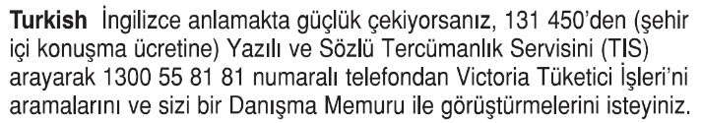


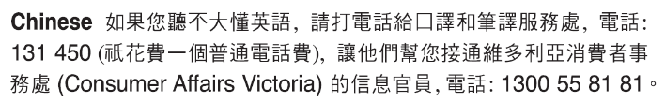
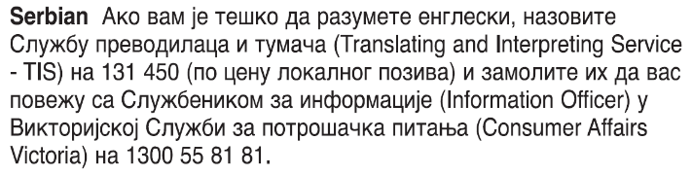



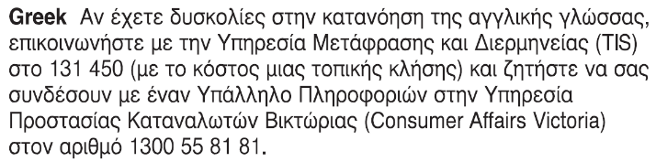
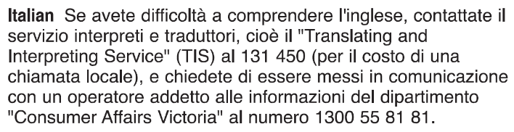 Information about renting is available in other languages at consumer.vic.gov.au/languages.

Notice to vacate to resident of SDA dwelling under Part 12A

Table 1: Reasons for giving notice to vacate
Reason and  Section number | Detail | Additional requirements
Unpaid rent  498ZX(1)(a) | You owe at least 14 days unpaid rent to the SDA provider. Rent is paid up to, and including _ /_ /_. $_ is owed | The resident must have first been given a breach of duty notice for not paying their rent and allowed 14 days to remedy the breach.
Danger  498ZX(1)(b) | You have endangered the safety of other SDA residents or staff at the SDA dwelling. | The resident must have been given a temporary relocation notice for the same reason 24 hours prior to this notice.  The SDA provider must believe the conduct constituting the breach is likely to reoccur to give this notice.  The SDA provider must take reasonable steps to notify the resident’s daily independent living support provider as soon as possible.
Disruption  498ZX(1)(c) | You are causing serious disruption to the proper use and enjoyment of the SDA dwelling by other residents. | The resident must have been given a temporary relocation notice for the same reason 24 hours prior to this notice.  The SDA provider must believe the conduct constituting the breach is likely to reoccur to give this notice.  The SDA provider must take reasonable steps to notify the resident’s daily independent living support provider as soon as possible
Danger to self  498ZX(1)(d) | You are a danger to themselves and can no longer be appropriately supported in the SDA dwelling. | The resident must have been given a temporary relocation notice for the same reason 24 hours prior to this notice.  The SDA provider must believe the conduct constituting the breach is likely to reoccur to give this notice.  The SDA provider must take reasonable steps to notify the resident’s daily independent living support provider as soon as possible.
Lack of appropriate support  498ZX(1)(e) | You can no longer be appropriately supported in the SDA dwelling. | The resident must have been given a temporary relocation notice for the same reason 24 hours prior to this notice.  The SDA provider must believe the conduct constituting the breach is likely to reoccur to give this notice  The SDA provider must take reasonable steps to notify the resident’s daily independent living support provider as soon as possible.
Serious damage  498ZX(1)(f) | You have caused serious damage or have destroyed any part of the SDA dwelling. | The resident must have been given a temporary relocation notice for the same reason 24 hours prior to this notice.  The SDA provider cannot give the notice if fair wear and tear, accidental damage, reasonable use of any aids or equipment, or any behaviour arising from the resident’s disability significantly contributed to the damage. The SDA provider must believe the conduct constituting the breach is likely to reoccur to give this notice.  The SDA provider must take reasonable steps to notify the resident’s daily independent living support provider as soon as possible.
Used for illegal purposes  498ZX(1)(g) | You have used the SDA dwelling for an illegal purpose. | The resident must have been given a temporary relocation notice for the same reason 24 hours prior to this notice.  The SDA provider must believe the conduct constituting the breach is likely to reoccur to give this notice.
Repairs to dwelling  498ZX(1)(h) | The SDA provider intends to repair, renovate or reconstruct the SDA dwelling immediately after the termination date and the SDA provider has obtained all necessary permits to carry out the work, and the work cannot be properly carried out unless you vacate the SDA dwelling | The resident must have been given a temporary relocation notice for the same reason 24 hours prior to this notice.  Important  Where:  - the proposed repairs, renovations or reconstruction will affect the SDA resident’s area or room but will not affect all areas or rooms in the dwelling; and  - an area or room equivalent to the SDA resident’s area or room at an equivalent rent is available in the dwelling  A notice must not be given unless the SDA provider has first offered an equivalent area or room to the SDA resident and the resident has refused to occupy that area or room.  The notice must be accompanied by supporting documentary evidence approved by the Director of Consumer Affairs (if any).
Demolition of dwelling  498ZX(1)(ha) | The SDA provider intends to demolish the dwelling immediately after the termination date and the SDA provider obtained all necessary permits to carry out the work, and the work cannot be properly carried out unless you vacate the SDA dwelling
Dwelling to be sold  498ZX(1)(k) | The SDA dwelling is to be sold or offered for sale with vacant possession (that is, there are no other residents living in the dwelling) | The notice must be accompanied by supporting documentary evidence approved by the Director of Consumer Affairs (if any).
Failure to comply with VCAT order  498ZX(1)(l) | You have failed to comply with a VCAT order made under section 498ZS. | The SDA provider cannot give the notice if reasonable use of any aids or equipment or any behaviour arising from the resident’s disability significantly contributed to resident’s failure to comply with the VCAT order.
Mortgagee entitled to possession gives notice to vacate  498ZZD | I am the mortgagee of the SDA dwelling and I am entitled to possession of the dwelling or to sell the dwelling under a mortgage. | The mortgagee must sign the notice and give a copy to the SDA resident and the SDA resident’s guardian or administrator, where applicable.
Owner of the SDA dwelling gives notice to vacate  498ZZCA | I am the owner of the SDA dwelling and am exercising my right to issue a notice to vacate for one of the other reasons specified above or to recover possession of the dwelling. | A notice under this section does not have effect unless it includes a termination date which is after the day on which the SDA provider’s interest in the premises ends.

How to serve this notice
The notice must be given by post, by delivering it personally to the resident between 8 am and 6 pm, or by email (with consent).
You can only give this notice by email if you already have the resident’s written consent to receive notices and other documents this way. You and the resident may have consented to electronic service of notices and other documents in the SDA residency agreement.
You must give a copy of the notice to the resident’s guardian or administrator if any.
You must also explain the notice to vacate in a language, mode of communication and terms the resident is likely to understand. If it will help the resident, you must explain it orally and in writing.
If it will help the resident, you must also give a copy of the notice to the resident’s family member, carer, advocate or other chosen support person. If the resident has not chosen a support person, you can choose a person to assist the resident that is not your employee or representative.
If you need help with this notice, visit the Notices to end an SDA residency - Consumer Affairs Victoria (consumer.vic.gov.au/sda)
or call the SDA support line on 1300 40 43 19.

Notice to vacate to resident of SDA dwelling

SDA Resident’s copy
Residential Tenancies Act 1997 S.498ZX, 498ZZD, 498ZZCA

SDA resident details
This notice is given to (resident/s name):
If applicable, a copy of this notice is also given to: (insert name and address of resident’s family member, carer, advocate, guardian, administrator or other chosen person)
Regarding the SDA dwelling at: (write address)
Resident’s address
(if same address as 2, write ‘as above’)

SDA provider/mortgagee/owner details
I am giving you this notice as: (mark one only)
the SDA provider:
the mortgagee:
the owner:

SDA provider/mortgagee/owner name: (cannot be agent’s name)
SDA provider/mortgagee/owner address for serving documents: (can be an agent’s address)
Contact telephone numbers for SDA provider/mortgagee/owner: (can be agent’s telephone number)
Business hours:
After hours:

Termination date
The Residential Tenancies Act 1997 requires me to give you at least 90 days to vacate:
I require you to vacate on: | / /

Reason for notice to vacate
Write the section number and the reason, using the words provided in Table 1.
Note: If given under 498ZX(1)(h) or (k), this notice must be accompanied by supporting documentary evidence approved by the Director of Consumer Affairs Victoria (if any).

Outline of circumstances giving rise to this notice
Please provide details of the circumstances that support the issuing of this notice:

Service details
This notice is given: (mark one method only and if registered post note the delivery speed)
by hand:
by registered post:
by email:
Insert email address:
(if applicable)
on this date: | / /

Note: A copy of this notice must be given to the resident’s guardian or administrator (if any).

Signature of SDA provider, their authorised officer or agent:
Name of SDA provider, their authorised officer or agent signing this notice:

Challenging this notice
If you have been given notice to vacate you may apply to the Victorian Civil and Administrative Tribunal (VCAT) to challenge the notice under s.498ZZC. You must apply within 90 days of the date of this notice.
It is recommended that you obtain independent legal advice if you wish to challenge the notice to vacate in VCAT.
Alternatively, you may be able to end the tenancy earlier than the date the SDA provider has given you in the Notice to vacate. Under s.498ZZA you can give the SDA provider written notice of your intention to vacate at any time and specify your own termination date.
You can do this using a Notice of intention to vacate form which is available via Consumer Affairs Victoria – Forms and publications.
You can call Consumer Affairs Victoria SDA support line on 1300 40 43 19 or visit consumer.vic.gov.au/sda

Notice to vacate to resident of SDA dwelling SDA resident support person’s copy
Residential Tenancies Act 1997 S498ZX; Regulation *

Resident details
- This notice is given to (resident’s name):
If applicable a copy of this notice is also given to: (insert name and address of resident’s family member, carer, advocate, guardian, administrator or other chosen person)
Regarding the SDA dwelling at: (write address)
Resident’s address
(if same address as 2, write ‘as above’)

SDA provider’s details
SDA provider’s name:
SDA provider address for serving documents:
Contact telephone numbers for SDA provider:
Business hours:
After hours:

Termination date
The Residential Tenancies Act 1997 requires me to give you at least 90 days to vacate:
I require you to vacate on: | / /

Reason for notice to vacate
Write the section number and the reason, using the words provided in Table 1.
Note: If given under 498ZX(1)(h) or (k), this notice must be accompanied by supporting documentary evidence approved by the Director of Consumer Affairs Victoria (if any).

This notice is given: (mark one method only and if registered post note the delivery speed)
by hand:
by registered post:
by email:
Insert email address:
(if applicable)
on this date: | / /
Signature of SDA provider:
Name of SDA provider:

Challenging this notice
If you have been given notice to vacate you may apply to the Victorian Civil and Administrative Tribunal (VCAT) to challenge the notice under s.498ZZC. You must apply within 90 days of the date of this notice.
It is recommended that you obtain independent legal advice if you wish to challenge the notice to vacate in VCAT.
Alternatively, you may be able to end the tenancy earlier than the date the SDA provider has given you in the Notice to vacate. Under s.498ZZA you can give the SDA provider written notice of your intention to vacate at any time and specify your own termination date.
You can do this using a Notice of intention to vacate form which is available via Consumer Affairs Victoria – Forms and publications.
You can call Consumer Affairs Victoria SDA support line on 1300 40 43 19 or visit consumer.vic.gov.au/renting

Notice to vacate to resident of SDA dwelling SDA Provider’s Copy

Residential Tenancies Act 1997 S498ZX; Regulation *

Resident details
- This notice is given to (resident’s name):
A copy of this notice is also given to: (if applicable, insert name and address of resident’s family member, carer, advocate, guardian, administrator or other chosen person)
Regarding the SDA dwelling at: (write address)
Resident’s address
(if same address as 2, write ‘as above’)

SDA provider’s details
SDA provider’s name:
SDA provider address for serving documents:
Contact telephone numbers for SDA provider:
Business hours:
After hours:

Termination date
The Residential Tenancies Act 1997 requires me to give you at least 90 days to vacate:
I require you to vacate on: | / /

Reason for notice to vacate
Write the section number and reason for the notice to vacate (selected from Table 1.
Note: If given under 498ZX(1)(h) or (k), this notice must be accompanied by supporting documentary evidence approved by the Director of Consumer Affairs Victoria (if any).

This notice is given: (mark one method only and if registered post note the delivery speed)
by hand:
by registered post:
by email:
Insert email address:
(if applicable)
on this date: | / /
Signature of SDA provider:
Name of SDA provider:

