Notice of intention to terminate
Residential Tenancies Act 1997, Part 12A
Specialist Disability Accommodation Section 498ZW (2)
Note:
Use this form if you are a specialist disability accommodation (SDA) resident to issue a notice of intention to terminate to the SDA provider (the provider) because they did not give you an information statement.
Enter text in spaces provided only.
Give this form to the SDA provider.
This document is available for download at consumer.vic.gov.au/forms.

How to serve this notice
You can give this notice by post, or deliver it personally to the provider between 8am and 6pm, or email it (with consent).
You can only give this notice by email if you already have the provider’s written consent to receive notices and other documents this way.
You and the provider may have consented to electronic service of notices and other documents in the SDA residency agreement.

Telephone Interpreter Service
If you have difficulty understanding English, contact the Translating and Interpreting Service (TIS) on 131 450 (for the cost of a local call) and ask to be put through to an Information Officer at Consumer Affairs Victoria on
1300 55 81 81.
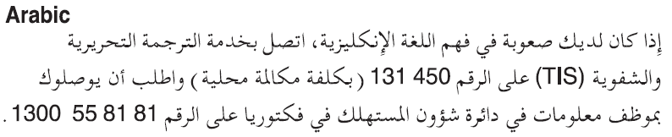
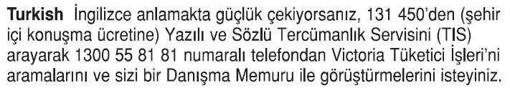
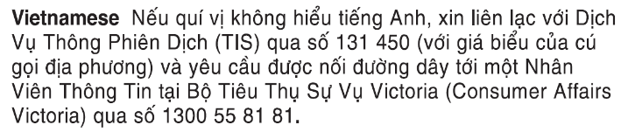

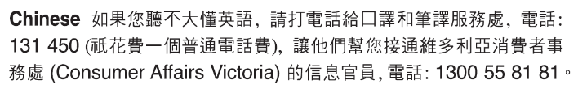
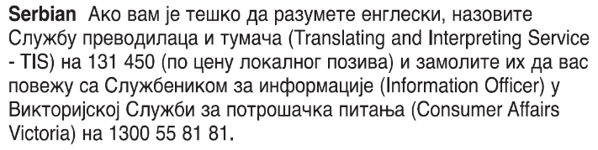

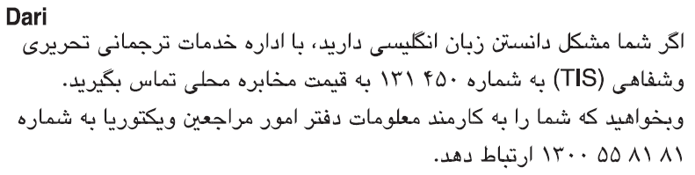
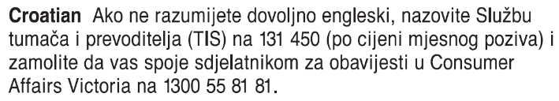
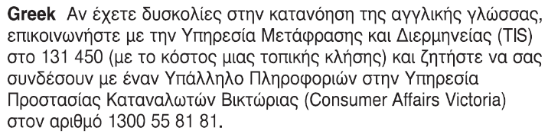
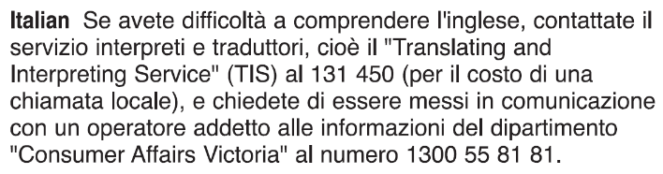 Information about renting is available in other languages at consumer.vic.gov.au/languages.

Notice of intention to terminate SDA resident’s copy
Residential Tenancies Act 1997 S498ZW (2)

SDA provider details
- This notice is given to:
(SDA provider’s name)
SDA provider’s address:
(can be an agent’s address)

SDA resident details
SDA resident’s name:
This notice is given on behalf of the resident by the SDA resident’s guardian or administrator:
(if applicable, write name below)
Regarding the SDA dwelling at:
(write address)
Address for serving documents:
(if the same as in 5, write ‘as above’)
SDA resident’s contact telephone numbers:
Business hours:
After hours:

Service details
This notice is given:
(mark one method only and if posted, note the delivery speed)
By hand:
By registered post:
By ordinary post:
By email:
Insert email address:
(if applicable)
On:  (dd/mm/yyyy) | / /
I intend to terminate the SDA residency agreement on:
Date:  (dd/mm/yyyy) | / /
This is because you did not provide me with an information statement (as required under the law) before I entered into the agreement.
Within 24 hours of receiving this notice you (the SDA provider) must give a copy of this notice to:
the NDIA CEO (if this notice has been given to you by a resident who is an NDIS participant)
the SDA resident’s guardian or administrator (if this notice has been given to you by the resident)
the Director of Consumer Affairs Victoria. To send a copy to us, visit Notice details | Enter a notice given to an SDA resident
After receiving this notice, Consumer Affairs Victoria will provide a copy of the notice to the Public Advocate. For SDA residents who are funded by the Transport Accident Commission or the Victorian WorkSafe Authority, Consumer Affairs Victoria will also send them a copy of the notice.
Signature of SDA resident:
(or guardian or administrator if applicable)

Notice of intention to terminate SDA resident support person’s copy
Residential Tenancies Act 1997 S498ZW (2)

SDA provider details
- This notice is given to:
(SDA provider’s name)
SDA provider’s address:
(can be an agent’s address)

SDA resident details
SDA resident’s name:
This notice is given on behalf of the resident by the SDA resident’s guardian or administrator:
(if applicable, write name below)
Regarding the SDA dwelling at:
(write address)
Address for serving documents:
(if the same as in 5, write ‘as above’)
SDA resident’s contact telephone numbers:
Business hours:
After hours:

Service details
This notice is given:
(mark one method only and if posted, note the delivery speed)
By hand:
By registered post:
By ordinary post:
By email:
Insert email address:
(if applicable)
On:  (dd/mm/yyyy) | / /
I intend to terminate the SDA residency agreement on:
Date:  (dd/mm/yyyy) | / /
This is because you did not provide me with an information statement (as required under the law) before I entered into the agreement.
Within 24 hours of receiving this notice you (the SDA provider) must give a copy of the notice to:
the NDIA CEO (if this notice has been given to you by a resident who is an NDIS participant)
the SDA resident’s guardian or administrator (if this notice has been given to you by the resident)
the Director of Consumer Affairs Victoria. To notify us, visit Notice details | Enter a notice given to an SDA resident
After receiving this notice, Consumer Affairs Victoria will provide a copy of the notice to the Public Advocate. For SDA residents who are funded by the Transport Accident Commission or the Victorian WorkSafe Authority, Consumer Affairs Victoria will also send them a copy of the notice.

Signature of SDA resident
(or guardian or administrator if applicable):

Notice of intention to terminate SDA provider’s copy
Residential Tenancies Act 1997 S498ZW (2)

SDA provider details
- This notice is given to:
(SDA provider’s name)
SDA provider’s address:
(can be an agent’s address)

SDA resident details
SDA resident’s name:
This notice is given on behalf of the resident by the SDA resident’s guardian or administrator:
(if applicable, write name below)
Regarding the SDA dwelling at:
(write address)
Address for serving documents:
(if the same as in 5, write ‘as above’)
SDA resident’s contact telephone numbers:
Business hours:
After hours:

Service details
This notice is given:
(mark one method only and if posted, note the delivery speed)
By hand:
By registered post:
By ordinary post:
By email:
Insert email address:
(if applicable)
On:  (dd/mm/yyyy) | / /

I intend to terminate the SDA residency agreement on:
Date:  (dd/mm/yyyy) | / /

This is because you did not provide me with an information statement (as required under the law) before I entered into the agreement.
Within 24 hours of receiving this notice you (the SDA provider) must give a copy of this notice to:
the NDIA CEO (if this notice has been given to you by a resident who is an NDIS participant)
the SDA resident’s guardian or administrator (if this notice has been given to you by the resident)
the Director of Consumer Affairs Victoria. To notify us, visit consumer.vic.gov.au/SDAnotify.
After receiving this notice, Consumer Affairs Victoria will provide a copy of the notice to the Public Advocate. For SDA residents who are funded by the Transport Accident Commission or the Victorian WorkSafe Authority, Consumer Affairs Victoria will also send them a copy of the notice.

Signature of SDA resident:
(or guardian or administrator if applicable)

